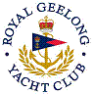 | Royal Geelong Yacht Club Inc.  Est 1859
Not a Trophy Deed of Gift.

Trophy: | Garner Family Trophy
Presented by: | Past Commodore and Life Member: John Garner
Date: | March 2022
For: | Best Performing Male Skipper at Vic Cadet Championship event
Remarks / Revisions | Property of 6th fleet. This is only a reference document

Click HERE to view the female equivalent

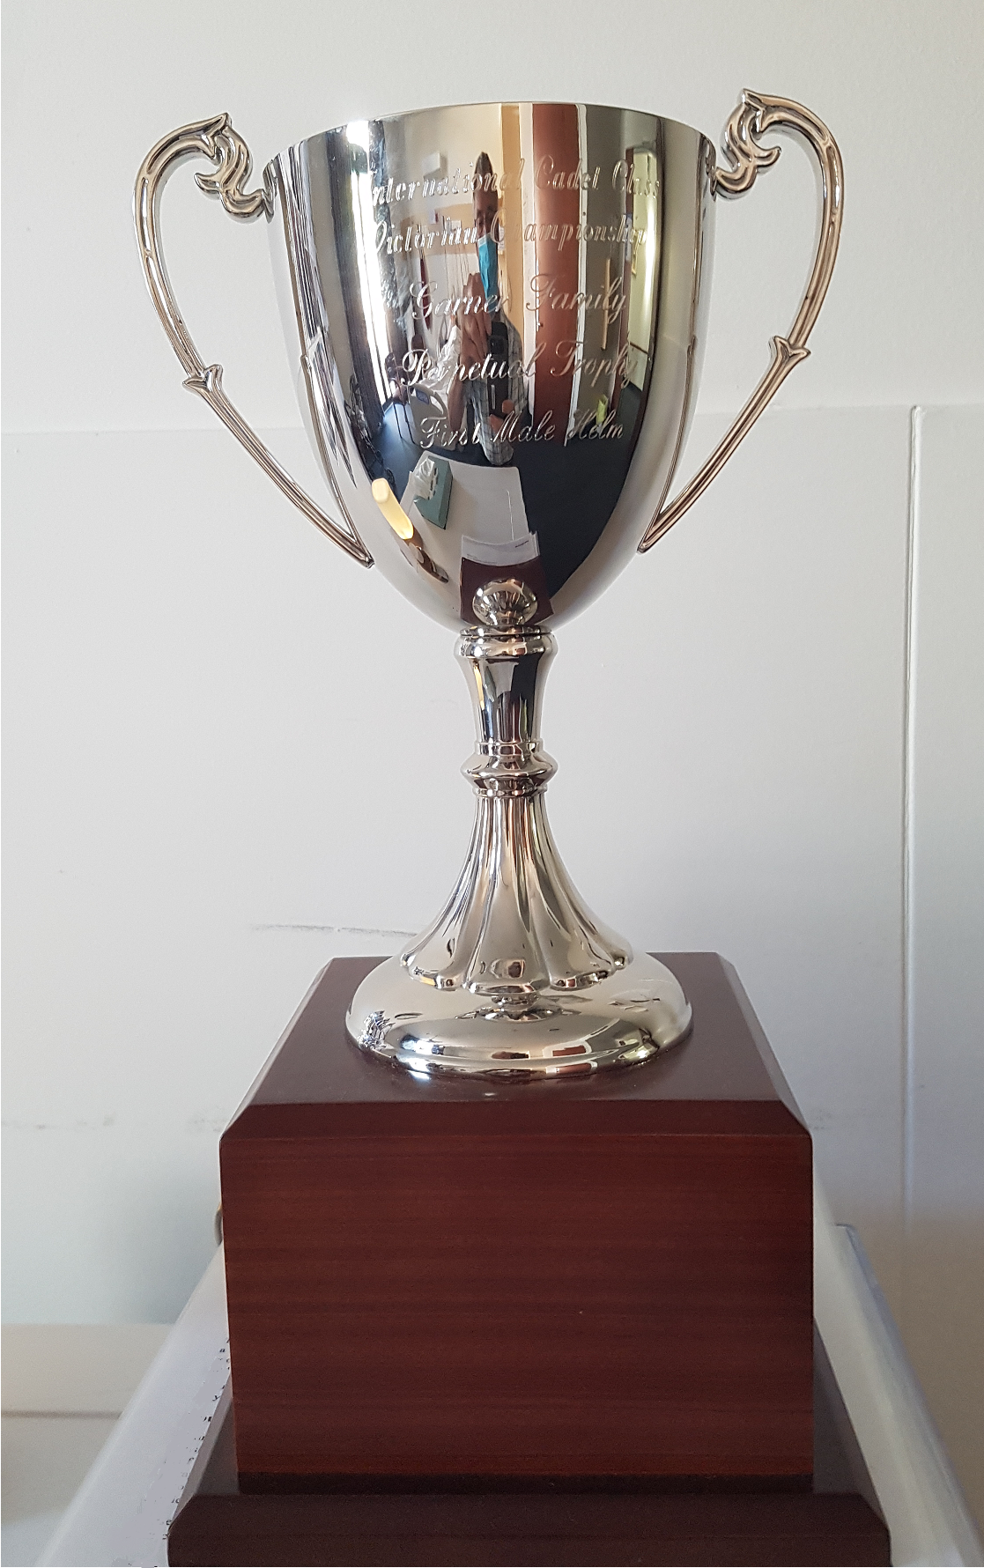
John Garner

